**Siddharth Balaji**

**Wi-Fi Training Program**

**Module – 1**

**Q1. In which OSI layer does the Wi-Fi standard/protocol fit?**

The Wi-Fi standard/protocol fits into Layer 1 (Physical) and Layer 2 (Data Link).

Physical Layer:

* The Physical Layer deals with the actual transmission and reception of data over the wireless medium.
* This involves radio frequency (RF) signals and the rules that govern how data is modulated and transmitted.
* The various Frequency bands include **2.4 GHz** (used in 802.11b/g/n), **5 GHz** (used in 802.11a/n/ac), **6 GHz** (used in Wi-Fi 6E and Wi-Fi 7)
* **Modulation techniques** include OFDM (Orthogonal Frequency Division Multiplexing) used in 802.11a/g/n/ac/ax and DSSS (Direct Sequence Spread Spectrum) used in 802.11b. Modulation means to convert digital data into radio waves for the purpose of transmission.
* Data rates and channels are also determined by Layer 1 (11 Mbps, 54 Mbps for data and 20 Mhz, 40 Mhz, 80 Mhz and 160 Mhz are frequency channels).
* **Antenna Technologies** are used to transmit and receive signals like MIMO (Multiple Input Multiple Output) which use multiple antennae for better data transmission.

Data Link Layer:

* Layer 2 is responsible for responsible for framing, addressing, and managing access to the shared wireless medium.
* Collisions are prevented, CSMA/CA (Carrier Sense Multiple Access with Collision Avoidance) allowing multiple devices to communicate efficiently via a wireless medium.
* Data is made into frames (management, control and data) and uses Circular Redundancy Check (CRC).
* **WPA/WPA2/WPA3 (Wi-Fi Protected Access)** is used for more secure encryption methods using AES. **802.1X Authentication** is used in enterprise Wi-Fi networks for authentication.

**Q2. Can you share the Wi-Fi devices that you are using day to day life, share that device’s wireless capability/properties after connecting to network. Match your device to corresponding Wi-Fi generations based on properties.**

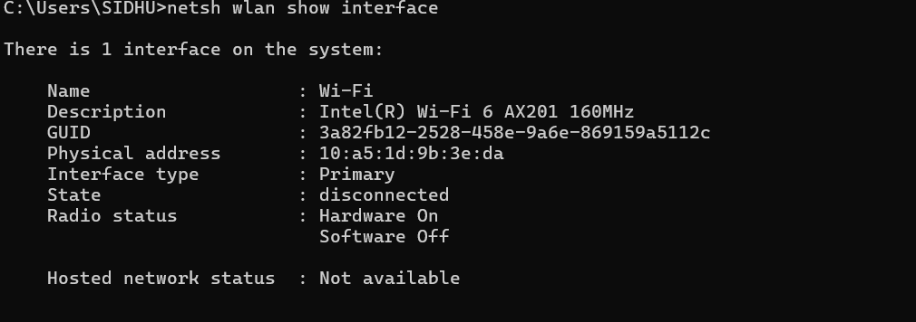

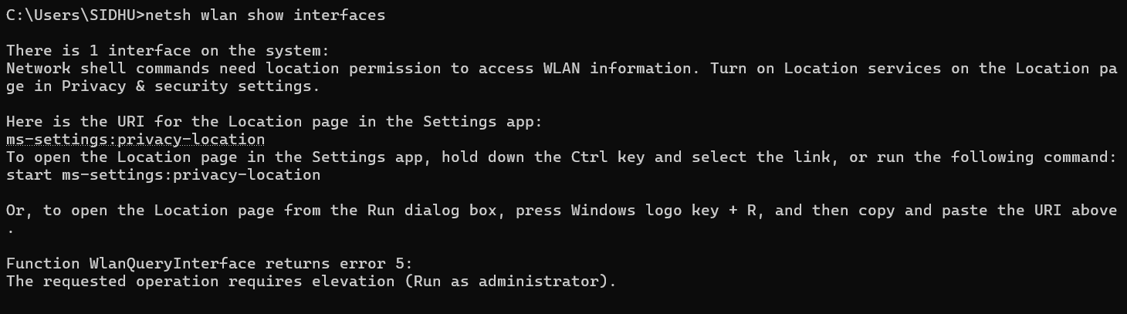

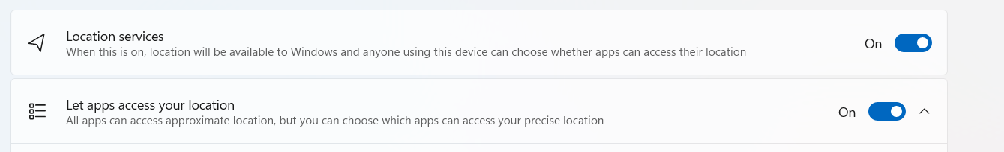

**On running the “netsh wlan show interface”, it requires the location to be turned and also requires elevation.**

**Hence, I ran the command in cmd as administrator and access is denied**

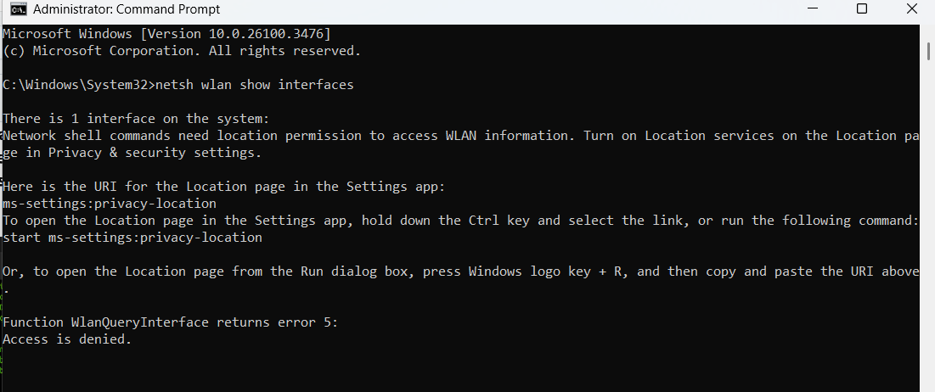

**Q3. What is BSS and ESS?**

**BSS (Basic Service Set):** A BSS is the fundamental building block of a Wi-Fi network, consisting of a single Access Point (AP) and the devices (stations) connected to it.

**Example:** The router is the single access point in our home with the other stations being our devices like laptop, smartphone and TV.

**ESS (Extended Service Set):** An ESS consists of multiple BSSs that are interconnected using a wired backbone (LAN). This setup allows devices to roam seamlessly between access points.

Multiple Access Points (APs), Same SSID (Network Name), Seamless Roaming (Handoff between APs), Large homes, offices, universities, and shopping malls, Public Wi-Fi hotspots (airports, hotels)

**Example:** A university campus Wi-Fi has different buildings where various departments are located and have their own APs but all use the same SSID (Wi-Fi name), allowing students to move around without disconnecting.

**Q4. What are the basic functionalities of Wi-Fi accesspoint.**

A Wi-Fi Access Point (AP) is a networking device that allows wireless devices to connect to a wired network using Wi-Fi.

**Wireless Connectivity**: Acts as a bridge between wired and wireless networks. Allows devices (laptops, phones, IoT devices) to connect without cables. Uses radio signals to transmit and receive data.

**Range Expansion:** In home/office networks, APs extend Wi-Fi coverage beyond the router’s range. Multiple APs in an Extended Service Set (ESS) enable seamless roaming.

**Network Authentication & Security**: Controls who can access the network using WPA2/WPA3 Encryption (Protects data from hackers), MAC Address Filtering (Allows only specific devices to connect), Captive Portals (Used in public networks for login authentication)

**Multiple Device Handling:** It allows us to manage multiple users connecting at the same time using band steering (directing devices to the best frequency band) and implements Quality of Service (QoS) to prioritize bandwidth for critical applications for video calls, gaming and more.

**Network Bridging:** It is used to connect wired devices (via Ethernet) to a wireless network and ca be used in businesses to connect printers, servers, and wired PCs to Wi-Fi users.

**Power over Ethernet (PoE) Support (For Business APs):** Enterprise-grade APs support PoE, allowing power and data to be delivered over a single Ethernet cable. It eliminates the need for separate power adapters. A lot of clutter and confusion that happens due to multiple cables can be avoided.

**Roaming & Handoff:** In an Enterprise Wi-Fi setup (ESS), APs allow seamless roaming between different access points without disconnecting. It ensures smooth transitions for users moving in a large area/network such as airports, hotels, offices and university campuses.

**Dual-Band & Multi-Band Support:** Modern APs operate on **both 2.4 GHz and 5 GHz bands** (some support 6 GHz with Wi-Fi 6E). 2.4 GHz will provide better range but slower speed while 5 GHz / 6 GHz will provide faster speed and lower interference.

**Guest Network Support:** Many APs allow a separate guest network which is used for isolating guest traffic from the main network for security reasons.

**Q5. Difference between Bridge mode and Repeater mode.**

|  |  |  |
| --- | --- | --- |
| **Features** | **Bridge Mode** | **Repeater mode** |
| **Function** | Connects two different networks enabling communication between them | Extends an existing network (doesn’t create a new network). |
| **Device Type** | Routers or access points | Repeater or extender |
| **Connection type** | Ethernet | wireless |
| **IP addressing** | Single subnet for all devices | Work like they’re connected to main network. |
| **Performance** | More efficient | Latency occurs because it is rebroadcasted each time. |
| **Best suited for** | Offices and enterprises with multiple buildings. | When home network has to be expanded |
| **Device connectivity** | Devices connect through a bridge for inter-network communication. | They are connected to the repeater just like any other Wi-Fi router. |

**Q6. What are the differences between 802.11a and 802.11b?**

|  |  |  |
| --- | --- | --- |
| **Features** | **802.11a** | **802.11b** |
| **Frequency Band** | 5 GHz | 2.4BHz |
| **Range** | Short (30m) | Longer (100m) |
| **Maximum Speed** | 54 Mbps (Faster speed is due to high frequency but travels less distance) | 11 Mbps (Slow speed is due to low frequency but it can travel farther) |
| **Interference** | Less interference and congestion due to 5 GHz. | More interference congestion because it is limited to 2.4 GHz |
| **Wall penetration** | Weak because of high frequency | Stronger due to low frequency. |
| **No. of channels** | 23 non-overlapping channels | 3 non-overlapping channels. |

**Q7. Configure your modem/hotspot to operate only in 2.4 GHz and connect your laptop/Wi-Fi device and capture the capability/properties in your Wi-Fi device. Repeat the same in 5 GHZ and tabulate all the differences you observed during this.**

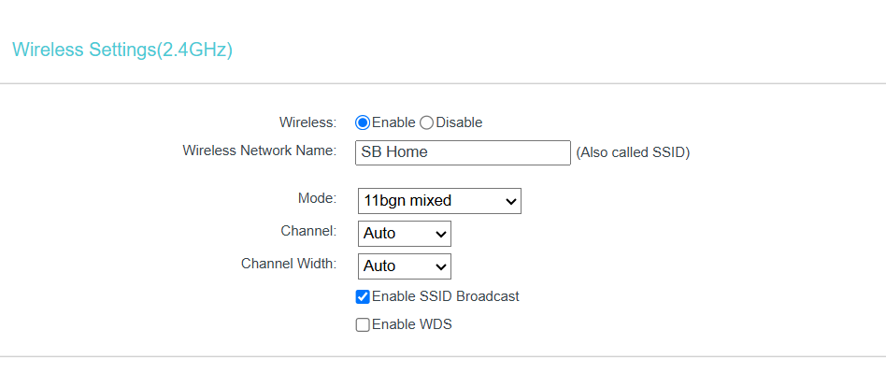

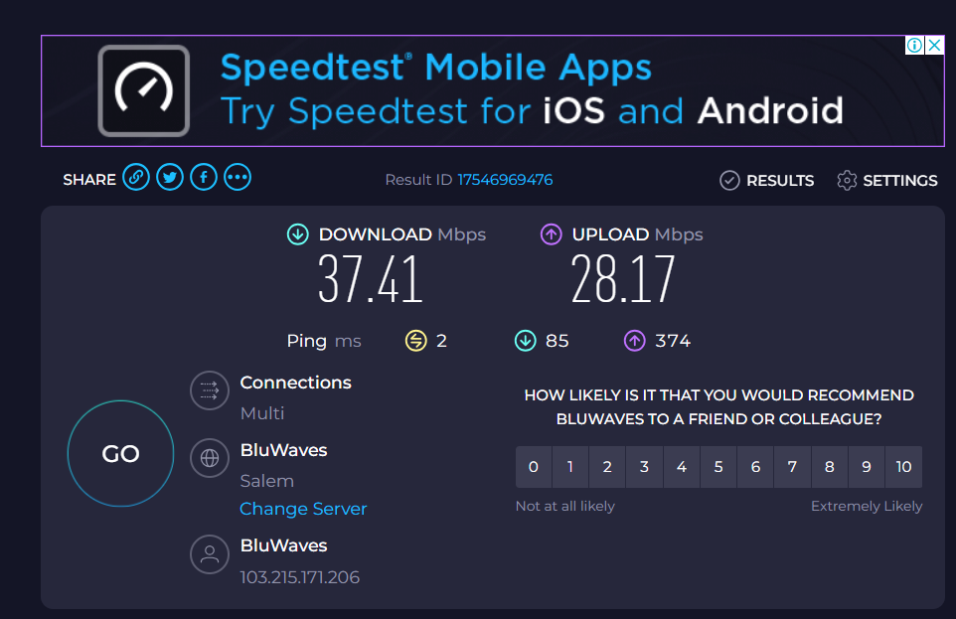

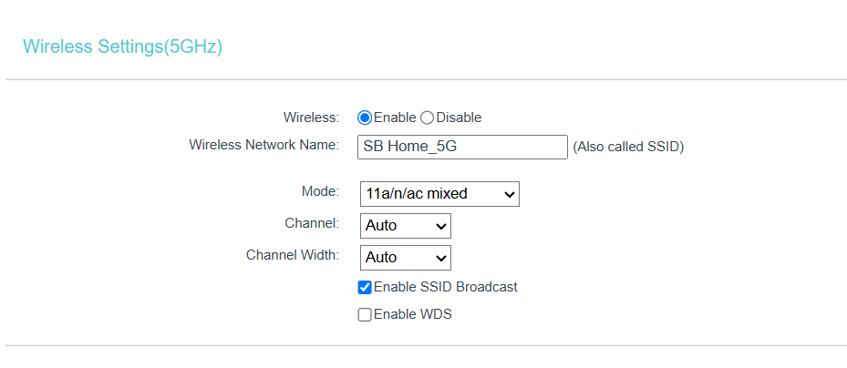

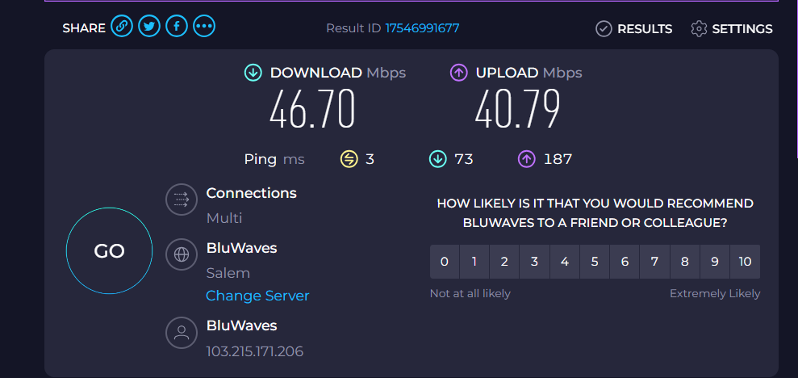

|  |  |  |
| --- | --- | --- |
| **Parameter** | **2.4GHz** | **5GHz** |
| **Download speed** | 37.41 | 46.70 |
| **Upload speed** | 28.17 | 40.79 |
| **Radio type** | 802.11bgn | 802.11a/n/ac |

**Q8. What is the difference between IEEE and WFA?**

|  |  |  |
| --- | --- | --- |
| **Feature** | **IEEE** | **WFA** |
| **Abbreviation** | Institute of Electrical and Electronics Engineers | Wi-Fi alliance |
| **Purpose** | Develops and defines standards, in our case networking | Certifies and promotes the use of Wi-Fi products of various manufacturers and ensure that the standards set by IEEE are met. |
| **Role** | It created the 802.11 Wi-Fi standard. | Ensures that the Wi-FI devices of various manufacturers have interoperability. |
| **Standards** | 802.11a/b/g/n/ac/ax | Wi-Fi 6 and 7 and further enhancements are certified. |
| **Users** | Researchers, engineers and companies can join as members. | Companies like Intel, Cisco, Qualcomm are some of the members. |

**Q9. List down the type of Wi-Fi internet connectivity backhaul, share your home/college’s wireless internet connectivity backhaul name and its properties.**

Wi-Fi backhaul refers to the method used to connect a local network (e.g., home, college, or office Wi-Fi) to the internet or a larger network.

It is an intermediate that connects local access points over fibre optic cables, wireless or satellite.

**Fibre optic backhaul**: It uses fibre-optic cables for high-speed internet connections with very high speed (Up to 10 Gbps), low latency and can be used in urban areas, data centres and universities.

**Ethernet Backhaul:** It uses wired Ethernet cables (to connect routers and access points with speed up to 10 Gbps, low latency. It is suitable for homes, office and businesses.

**Cellular Backhaul (4G and 5G):** It uses mobile networks (LTE, 5G) to provide internet with speed up to 10 Gbps, very low latency. It can be used in homes, offices, businesses, IoT devices and rural areas.

**Satellite Backhaul:** It uses satellites to provide internet connectivity with speed up to 300 Mbps, high latency (500 milliseconds or more). It can be used in remote locations, maritime, military and space communications like Starlink.

**Q10. List down the Wi-Fi topologies and use case of each one.**

|  |  |  |
| --- | --- | --- |
| **Topology** | **Description** | **Use case** |
| **Infrastructure mode** | **All devices connect through central router/AP** | **Home, Wi-Fi hotspots, enterprises** |
| **Mesh mode** | **Nodes are interconnected and directly communicate with each other.** | **IoT devices/networks, Smart cities.** |
| **Repeater mode (Extender)** | **Retransmits signals by using repeater to extend range.** | **Areas with dead spots.** |
| **Bridge mode** | **Two separate networks are connected.** | **LAN integration.** |
| **Ad-hoc mode** | **Devices connect directly without a router.** | **Gaming, Military** |